a



Company

Logotype

**Cone Beam Computed Tomography- Report**

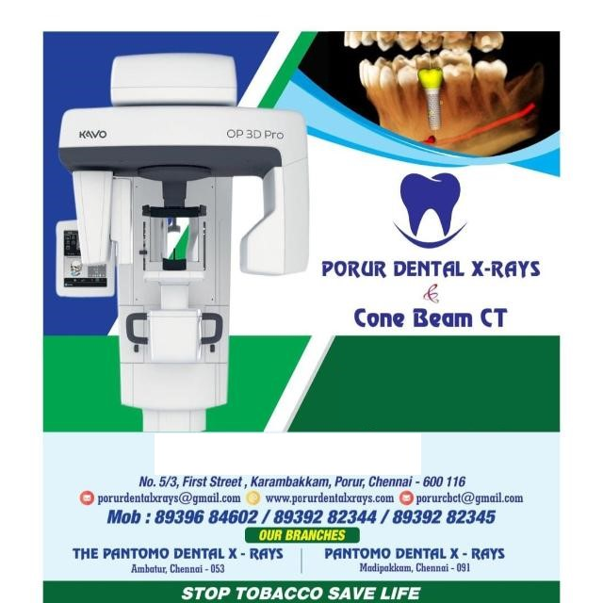



**Porur Dental X-rays & CBCT**

|  |  |
| --- | --- |
| **Patient Name :** Mrs. Bhagyavathy | **Date of Report :** 08.03.2025 |
| **Age/ Gender :** 38 years/ Female | **Region of Interest :** CBCT Maxilla |
| **Referring doctor:** Dr. Subramoniam | **Indication :** Assessment of surgical wire in relation to 21, 22, 23 |
| **Clinical Notes:** Nil | |

**PATIENT INFORMATION**

CBCT- Maxilla provided

**CBCT – IMAGE DETAILS**

**RADIOGRAPHIC INTERPRETATION**

* No of teeth present in the maxillary arch: 14; Missing teeth: 18, 28
* Presence of hyperdense surgical plates in relation to lateral wall of right and left maxillary sinus and the right lateral border of nasal cavity is evident
* Presence of hyperdense surgical wire that appears to be looped in relation to the left lateral wall of nasal cavity and medial wall of the left maxillary sinus is evident.
* The surgical wire is located at 5.35 mm above the apical region of 22 and 3.64 mm above the apical region of 23.
* There is mild discontinuity in relation to the medial and lateral wall of left maxillary sinus. Additionally there is evident mucosal sinus thickening in relation to floor, right and left walls of left maxillary sinus.

**RADIOGRAPHIC IMPRESSION**

* Surgical screws and plates in relation to maxillary and nasal region.
* Left maxillary sinusitis.

*Kindly correlate with clinical findings*

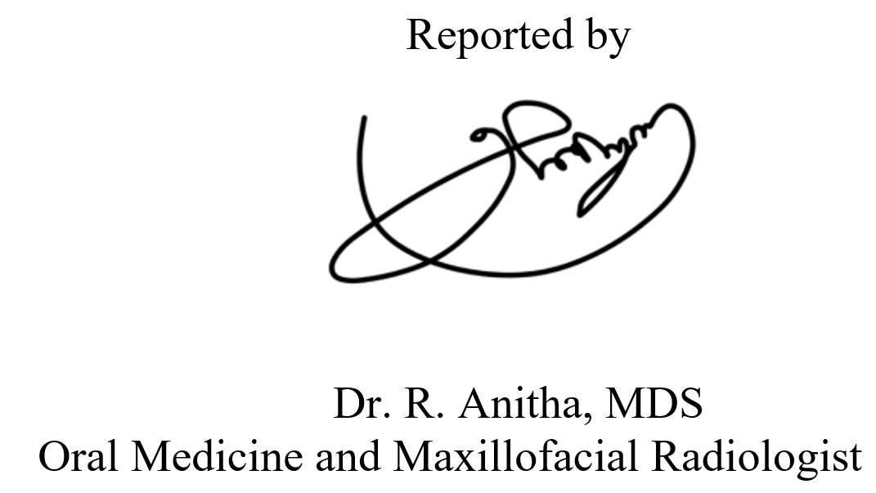

**IMAGES FOR REFERENCE**

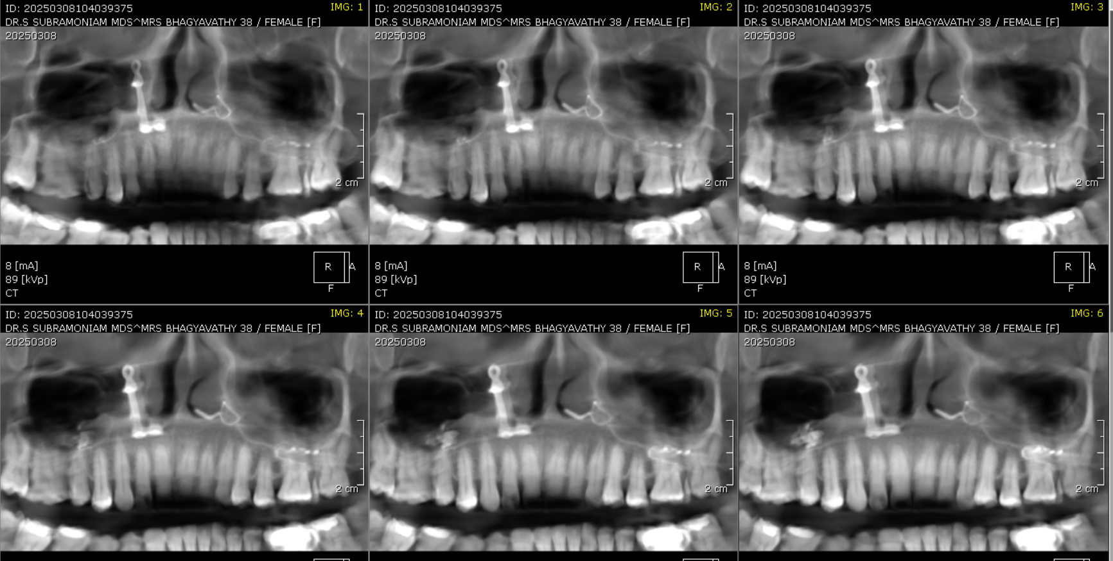**RECONSTRUCTED PANORAMIC VIEW**

**3-DIMENSIONAL VIEW**

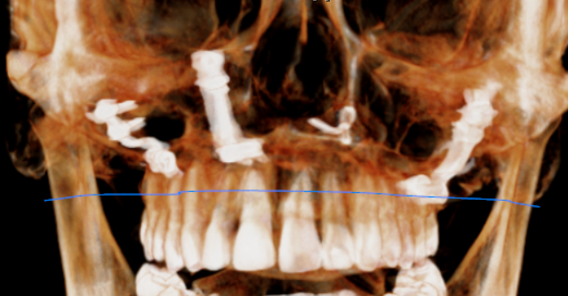

**CORONAL VIEW**

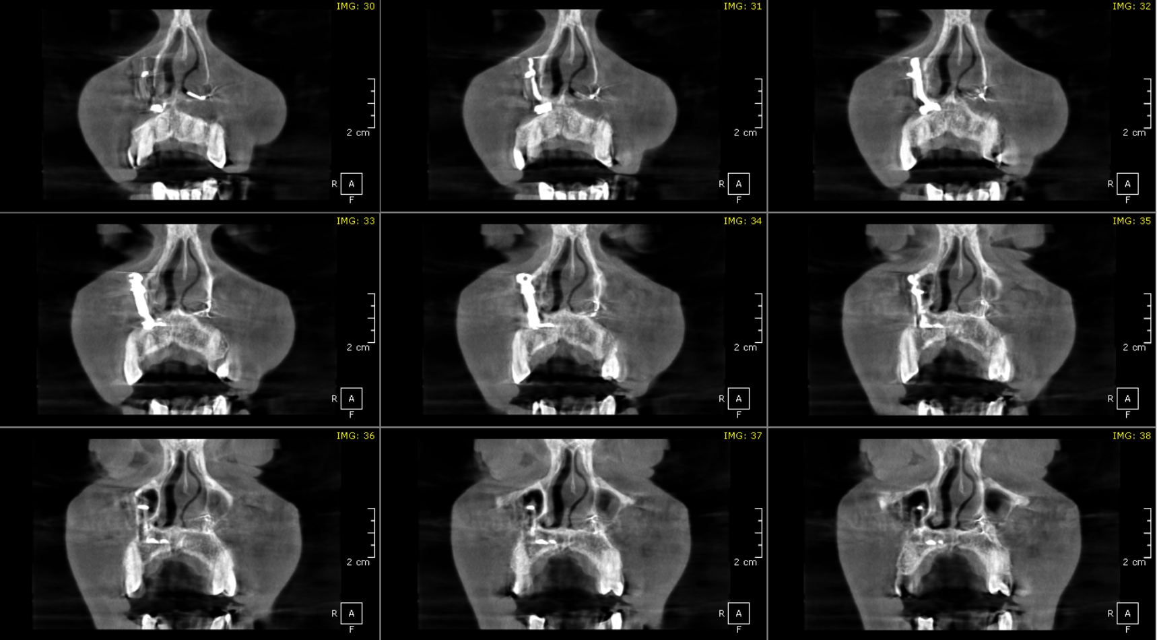

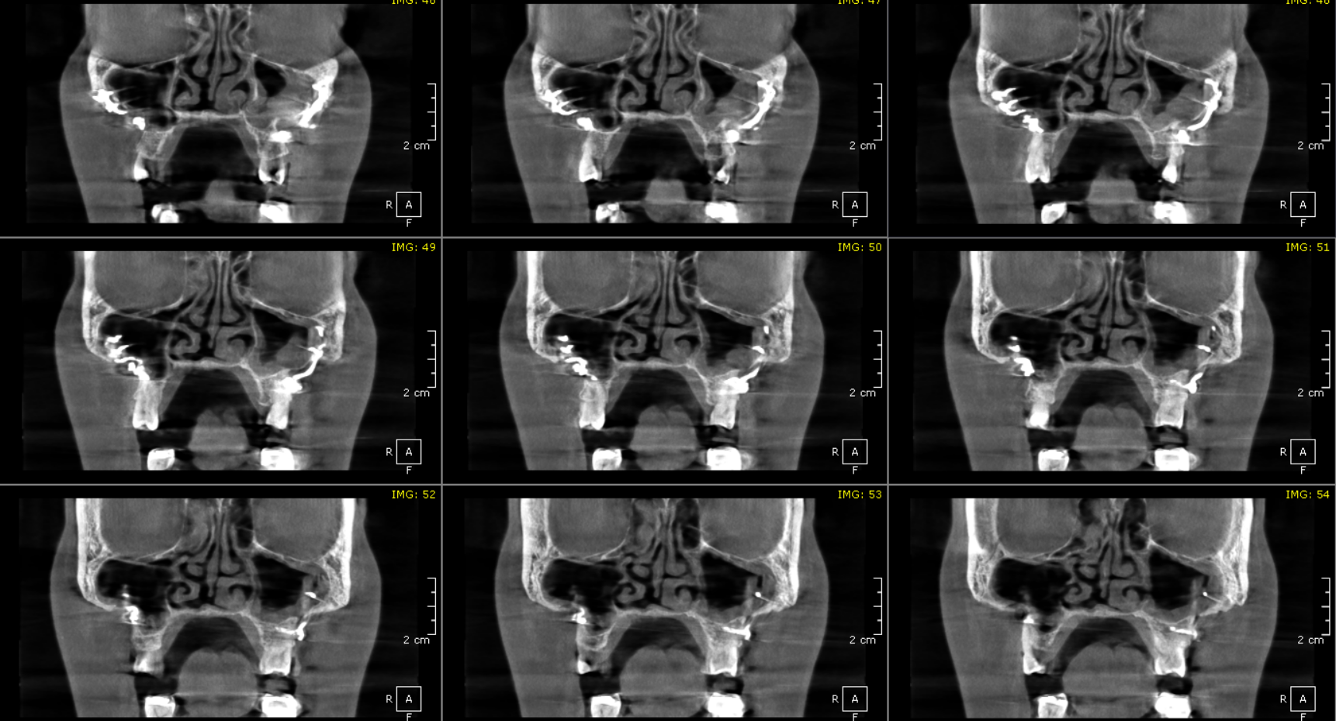

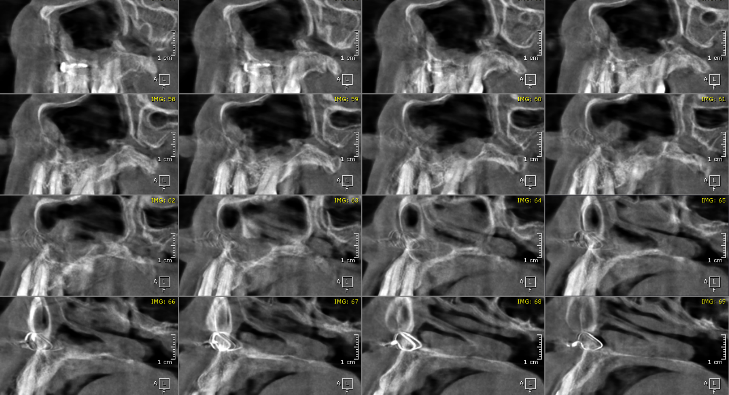**SAGITTAL VIEW**

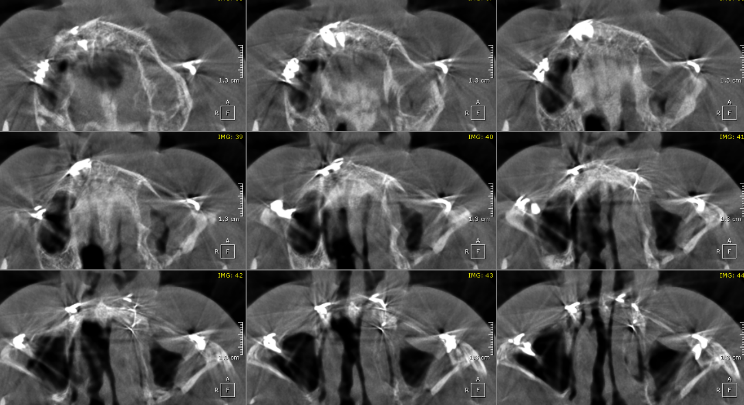**AXIAL VIEW**

**\*\*\* End of report \*\*\*\***